 **Introduction to DevOps**

**BCS/BS 6A**

Lab: 09

# GROUP MEMBERS:

MUHAMMAD SHAYAN SHAHID (2212325)

MUHAMMAD ASHAD BAIG (2212115)

Task 1: Create a Policy assignment

In this task, we will configure the Require a tag on resources policy and assign it to our subscription.

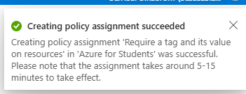

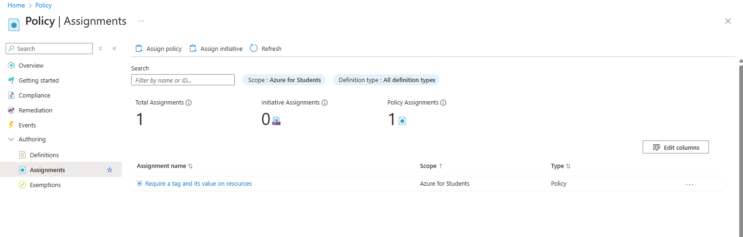

Task 2: Create a storage account to test the required tagging

In this task, we will create storage accounts to test the required tagging.

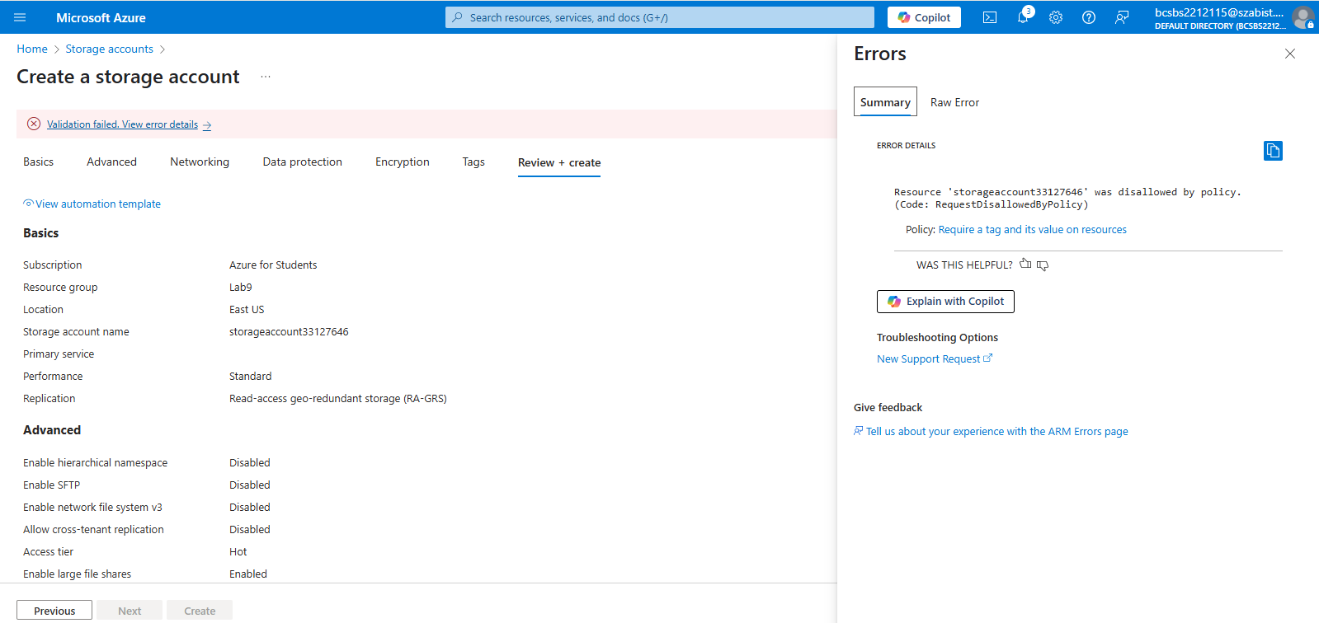

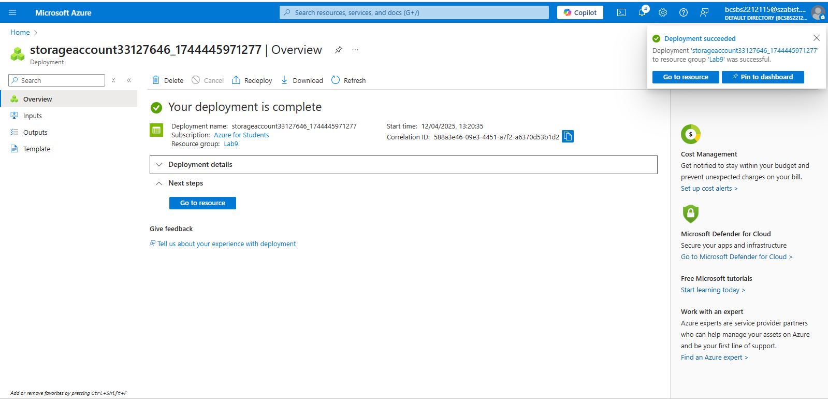

Task 3: View all resources with a specific tag

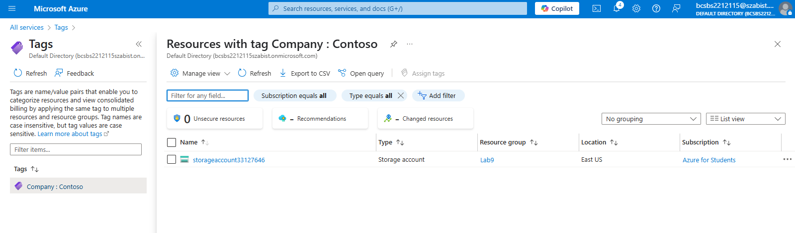

Task 4: Delete the policy assignment

In this task, we will remove the Require a tag on resources policy so it does not affect our future work.

